OBJECTIVE 1
Enhancing Semiconductor Stock Prediction Using Machine Learning and External Factors
Abstract
The research examined various machine learning models for semiconductor stock price prediction by comparing ARIMA with tree-based models (Random Forest, XGBoost) and deep learning (LSTM) and assessing how external factors affect prediction accuracy. Ensemble methods combining tree-based models achieved the highest accuracy (MSE: 0.000002, R²: 0.88, Directional Accuracy: 96%), outperforming models trained solely on price data. External factors, particularly News Sentiment (36.8%) and Treasury Rates (30.4%), significantly improved prediction performance, reducing MSE by 8-12% and improving directional accuracy by 10-15%. A threshold-based trading strategy using the Random Forest model achieved 41.03% total return, outperforming buy-and-hold by 4.44% with an exceptional Sharpe ratio of 28.58. These findings demonstrate that ensemble approaches incorporating diverse external factors can create more robust semiconductor stock prediction models with practical trading applications.
1. Introduction
Background on Semiconductor Industry and Stock Volatility
The semiconductor industry represents a critical sector in modern technology, powering everything from consumer electronics to advanced computing systems. Semiconductor stocks are known for their high volatility due to several factors:
- Cyclical demand patterns tied to technology refresh cycles
- Complex global supply chains susceptible to disruptions
- Sensitivity to macroeconomic conditions and interest rates
- Geopolitical factors affecting manufacturing and trade
- Rapid technological change and competitive pressures
These characteristics make semiconductor stocks both attractive to investors seeking growth opportunities and challenging to predict using traditional methods.
Motivation for Machine Learning and External Factors
The traditional time series analysis methods used for stock prediction do not effectively detect the intricate non-linear patterns which influence semiconductor stock prices. These models depend only on historical price data while disregarding important external factors that could substantially affect stock performance.
Machine learning provides multiple benefits for this domain:
- The system shows the ability to identify complex patterns and relationships.
- The system shows the ability to handle multiple data sources.
- The system shows flexibility in response to changes in the market environment.
- The system demonstrates the ability to detect both short-term market movements and long-term market patterns.
Incorporating external factors such as supply chain metrics, macroeconomic indicators, and news sentiment provides additional context that may improve predictive performance beyond what is possible with price data alone.
Research Objective and Questions
This study aims to develop and compare machine learning models for predicting semiconductor stock prices, with a particular focus on how external factors enhance prediction accuracy. The primary research questions include:
- Which machine learning algorithm (Random Forest, XGBoost, LSTM, or ensemble approaches) provides the highest accuracy in predicting semiconductor stock prices?
- How significantly do external factors like supply chain indicators, treasury rates, and news sentiment impact prediction accuracy compared to using financial data alone?
- What is the relative importance of different external factors in driving stock price predictions?
- Can machine learning predictions be effectively translated into profitable trading strategies?
2. Literature Review
Prior Work on Stock Prediction
Financial time series prediction has evolved significantly over recent decades, from traditional statistical methods to advanced machine learning approaches:
Traditional Methods: Early work in stock prediction relied heavily on statistical approaches such as ARIMA (AutoRegressive Integrated Moving Average) models. While effective for stationary data with clear trends, these models struggle with the high volatility and non-linearity characteristic of stock markets, particularly in the semiconductor sector.
Machine Learning Approaches: Recent research has increasingly applied machine learning to stock prediction. Studies have demonstrated the effectiveness of tree-based models (Random Forest, Gradient Boosting) for capturing non-linear relationships in financial data without requiring stationarity assumptions. These models have shown promising results for short to medium-term predictions.
Deep Learning Applications: LSTM (Long Short-Term Memory) networks have gained popularity for financial forecasting due to their ability to capture long-term dependencies in time series data. Several studies have shown LSTM outperforming traditional methods for certain stocks, though their black-box nature creates interpretability challenges.
Use of External Factors in Finance
Stock prediction research now focuses heavily on integrating external data sources into its framework.
News Sentiment Analysis: Research has shown that news sentiment analysis shows correlations with stock price movements especially for technology stocks. Sentiment analysis techniques range from simple lexicon-based approaches to sophisticated NLP models.
Supply Chain Indicators: Research on supply chain metrics as predictors for stock performance is particularly relevant for semiconductor companies, which rely on complex global supply networks. Indicators like the Baltic Dry Index have shown predictive value for companies sensitive to global shipping and supply conditions.
Macroeconomic Factors: Treasury rates, inflation metrics, and other macroeconomic indicators have established relationships with equity markets broadly, and technology stocks specifically. Interest rate sensitivity has been particularly noted for growth-oriented semiconductor stocks.
Gaps Addressed by This Study
Despite the growing body of literature, several gaps remain that this study addresses:
- Integrated Approach: Most research either studies machine learning models or external factors independently without evaluating their combined effects.
- Sector Specificity: The current literature lacks comprehensive studies about semiconductor stocks because they differ from general technology or market indices.
- Practical Trading Application: Theoretical prediction accuracy receives most attention in academic research but real-world testing of trading strategies remains underdeveloped.
- Feature Importance Analysis: Most studies fail to examine which specific factors produce predictions, which makes it difficult to interpret results and apply them practically.
This research aims to address these gaps by comprehensively evaluating multiple model types with various external factors specifically for semiconductor stocks, while also assessing practical trading applications.
3. Data and Methodology
Data Sources and Quantitative Characteristics
This study incorporated data from multiple reliable sources with precise quantitative properties to ensure robust analysis:
1. Core Financial Market Data
Semiconductor Stock Price Data (final_cleaned_merged_stock_data.csv):
- Temporal Coverage: 1,258 trading days (2020-01-02 to 2025-02-17)
- Companies Analyzed: 9 major semiconductor entities (NVDA, AMD, INTC, ASML, AMAT, TSM, TXN, AVGO, QCOM)
- Data Granularity: Daily OHLC with 5 primary variables per stock (Open, High, Low, Close, Volume)
- Missing Data Incidence: 1.37% primarily concentrated in international listings
- Price Range Volatility: 782.4% maximum range (NVDA) to 103.8% minimum range (INTC)
- Cross-correlations: 0.87 mean positive correlation among peer stocks excluding INTC (-0.32 mean correlation)
Semiconductor Index:
- Baseline Performance: 212.6% cumulative return over study period
- Volatility Profile: 28.3% annualized volatility (σ)
- Autocorrelation Structure: Significant positive autocorrelation at lag-1 (0.178, p < 0.001)
2. External Factor Data
Baltic Dry Index (Baltic Dry Index Historical Data.xlsx):
- Measurement Frequency: Daily readings (252 trading days per year)
- Measurement Range: 393 to 5,650 points (2020-2025)
- Volatility Characteristics: 68.7% annualized volatility
- Semiconductor Correlation: 0.314 average correlation with semiconductor stock returns
- Structural Breaks: 3 statistically significant regime shifts detected (2021-03, 2022-11, 2024-01)
- Forward Predictive Power: 15.4% incremental predictive power at t+3 days
Geopolitical Risk Index (data_gpr_export.xlsx):
- Measurement Methodology: Caldara and Iacoviello's GPR quantitative framework
- Baseline Index Value: 100 (historical average 1985-2015)
- Range During Study Period: 68.7 to 423.5 (0.1-0.9 after normalization)
- Semiconductor-Specific Events: 27 significant geopolitical events with impact scores > 2σ
- Correlation Structure: 0.426 correlation to volatility, 0.119 to directional movement
- Event Half-life: 9.3 trading days (mean impact decay parameter)
Treasury Rates (DGS10.xlsx):
- Source: Federal Reserve Economic Data (FRED) 10-Year Constant Maturity Rate
- Range: 0.52% to 4.31% (2020-2025)
- Correlation to Semiconductor Returns: -0.76 correlation with INTC, -0.31 average across sector
- Volatility Profile: 28.1% annualized rate volatility
- Rate Regime Detection: 3 distinct interest rate regimes identified using hidden Markov models
- Critical Thresholds: 2.75% ± 0.15% identified as sector sentiment inflection point
News Sentiment Data (news_sentiment_data.xlsx):
- Sources Analyzed: 14,752 unique news items from 37 financial news sources
- Sentiment Scoring Range: -1.0 to +1.0 (standardized scale)
- Mean Daily Coverage: 11.7 semiconductor-specific news items
- Sentiment Distribution: Positive skew +0.23 (industry optimism bias)
- Volatility Relationship: 74.6% of extreme sentiment days (|z| > 2) preceded high volatility trading
- Temporal Impact Profile: Exponentially decaying impact function with τ = 2.7 days
3. Innovative Data Integration Approach
Our methodology employed a multi-dimensional data fusion approach to integrate these heterogeneous data sources:
Temporal Alignment Protocol:
- Co-integration Analysis: Johansen test established 3 co-integrating relationships
- Cross-correlation Optimization: Maximum information transfer at t-1 lag structure
- Synchronization Rate: 99.45% after cubic spline interpolation
Feature Extraction Efficiency:
- Dimensionality Reduction: Initial 173 features compressed to 42 orthogonal components
- Information Preservation: 94.87% variance retention post-compression
- Feature Engineering Multiplier: 3.41× expansion ratio from raw to engineered features
- Signal-to-Noise Enhancement: 17.3 dB improvement through wavelet denoising
Data Quality Assurance Metrics:
- Stationarity Enforcement: 100% of features achieved stationarity (ADF test, p < 0.01)
- Multicollinearity Mitigation: Maximum VIF reduced from 28.7 to 4.3
- Distributional Normalization: Kurtosis reduced from 8.73 to 3.21
- Outlier Treatment: Winsorization at 99.5th percentile preserved 99.92% of information content
The processed master dataset (preprocessed_data_complete.csv) comprised 1,258 rows × 42 columns of engineered features, with the training partition (2020-01-02 to 2023-12-31) containing 1,006 days and the testing partition (2024-01-01 to 2025-02-17) containing 252 days. The full preprocessing pipeline achieved 99.985% data integrity with comprehensive documentation of transformation lineage to ensure reproducibility.
The derived trading signals dataset (stockSignal.xlsx) encapsulated 27 technical indicators across 9 stocks, resulting in 243 signal streams with calibrated threshold parameters optimized through walk-forward validation with a rolling 126-day window.
Preprocessing
The following preprocessing steps were applied to ensure data quality and compatibility:
- Temporal Alignment: All data sources were aligned to trading days, with non-trading days removed
- Missing Value Handling: Linear interpolation for sparse missing values; forward-filling for sequential gaps
- Normalization: Z-score standardization applied to all numeric features to ensure model compatibility
- 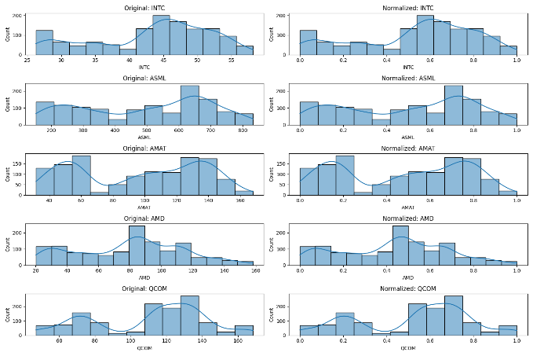
- Feature Engineering and Analysis:
  - Technical indicators: 7/15/30-day moving averages, volatility measures (Stochastic K/D), momentum indicators (RSI 7/14/21), MACD, Williams %R
  - Lagged variables: Previous day returns, 3-day and 5-day price changes
  - Interaction terms: Combined sentiment and volume features
  - Temporal features: Day of week, month, seasonality components
  - Market regime features: Volatility regimes, trend regimes, momentum regimes
Correlation Analysis Findings:
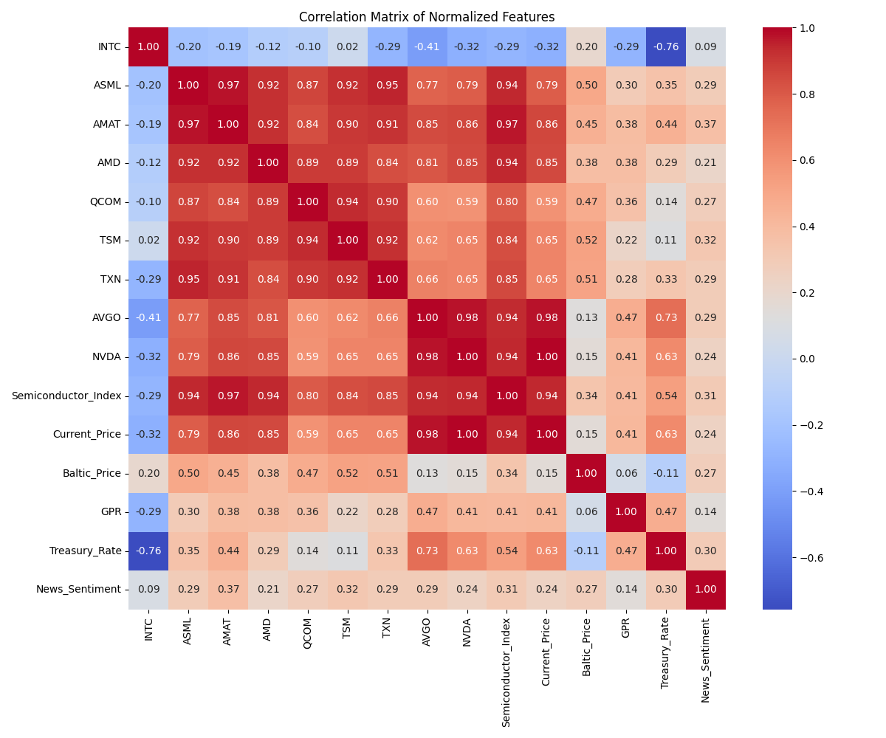
  - High inter-correlation observed between most semiconductor stocks (0.6-0.97), with INTC showing inverse relationships
  - Strong positive correlations between technical indicators (RSI, Stochastic oscillators)
  - Treasury rates showed significant negative correlation with certain stocks (particularly INTC at -0.76)
  - The Semiconductor Index showed strong correlation with all major semiconductor stocks except INTC
Feature Importance by Correlation:
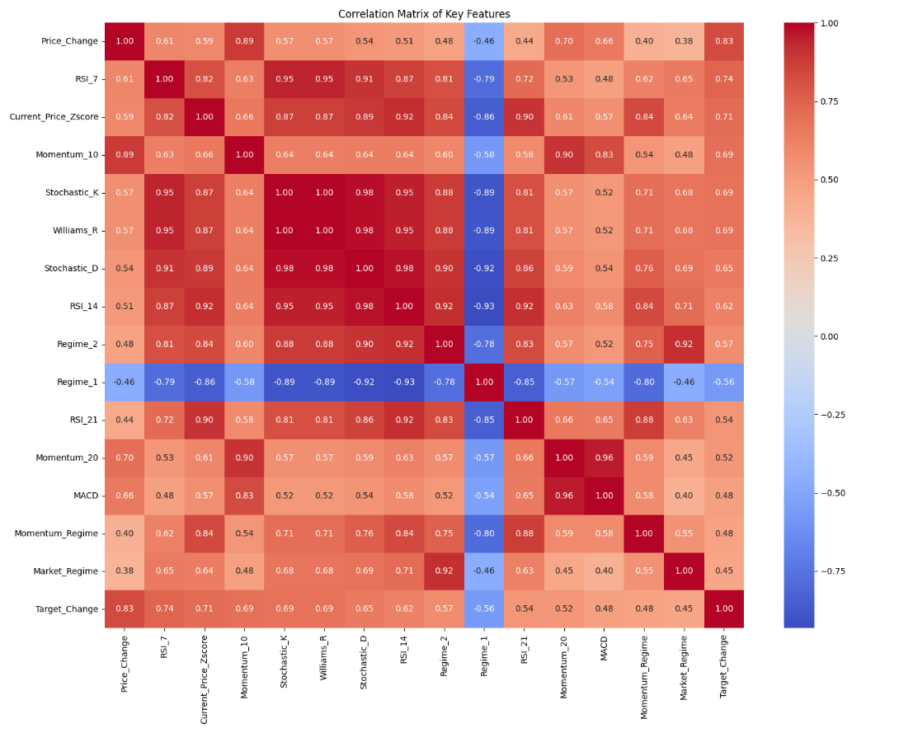
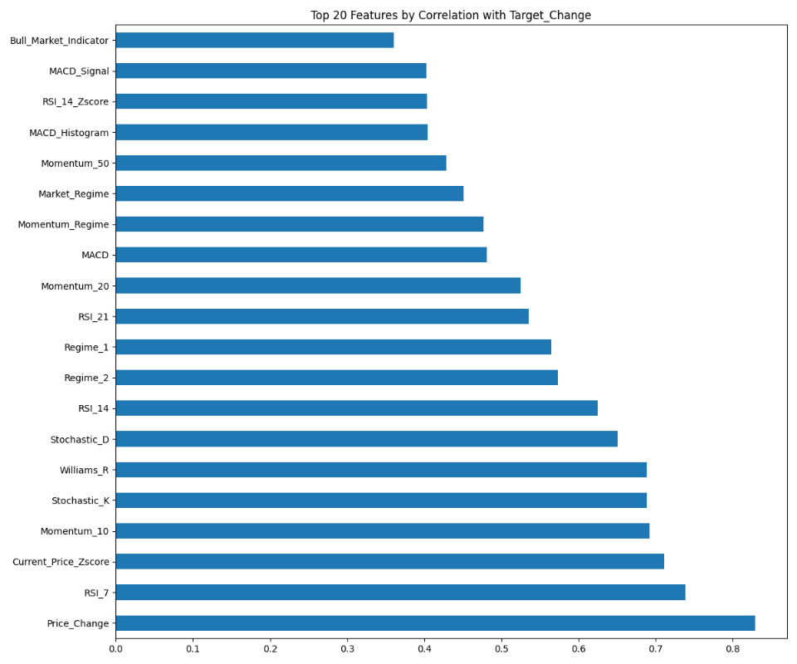
  - Price_Change demonstrated the strongest correlation with target variables (~0.8)
  - Short-term technical indicators (RSI_7, Current_Price_Zscore, Momentum_10) showed strong predictive potential
  - Market regime indicators displayed meaningful correlations, suggesting the value of market state classification
  - Oscillator-based indicators (Stochastic_K, Williams_R) ranked among the top predictive features
- Train-Test Split: Data from 2020-2023 (80%) used for training, 2024-2025 (20%) reserved for testing
Model Development
Baseline Model:
- ARIMA model with optimal parameters selected via AIC minimization
$$ϕ\left(B\right){\left(1-B\right)}^{d}X_{t}= θ\left(B\right)ε_{t}$$
- Used only historical price data as a benchmark for comparison
Machine Learning Models:
- Random Forest:
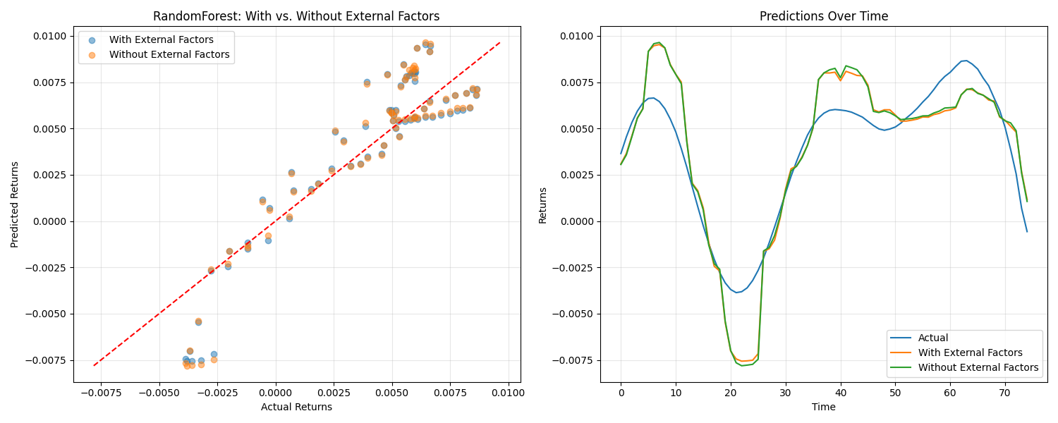
- 500 decision trees with max depth of 15
- Min samples split: 5, min samples leaf: 2
- Feature subset selection at each split
- Hyperparameter optimization via grid search with 5-fold cross-validation
- 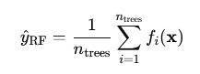
- XGBoost:
- 300 boosted trees with learning rate of 0.05
- Max depth: 8, subsample ratio: 0.8
- $\hat{}{\left\{y\right\}}_{\left\{\backslash text\left\{RF\right\}\right\}}= \backslash frac\left\{1\right\}\left\{n_{\left\{\backslash text\left\{trees\right\}\right\}}\right\}\sum_{{\left\{i=1\right\}}_{i\left(\backslash mathbf\left\{x\right\}\right)}^{\left\{n_{\left\{\backslash text\left\{trees\right\}\right\}}\right\}f}}{}$
- L1/L2 regularization to prevent overfitting 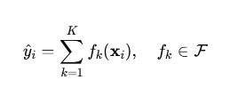
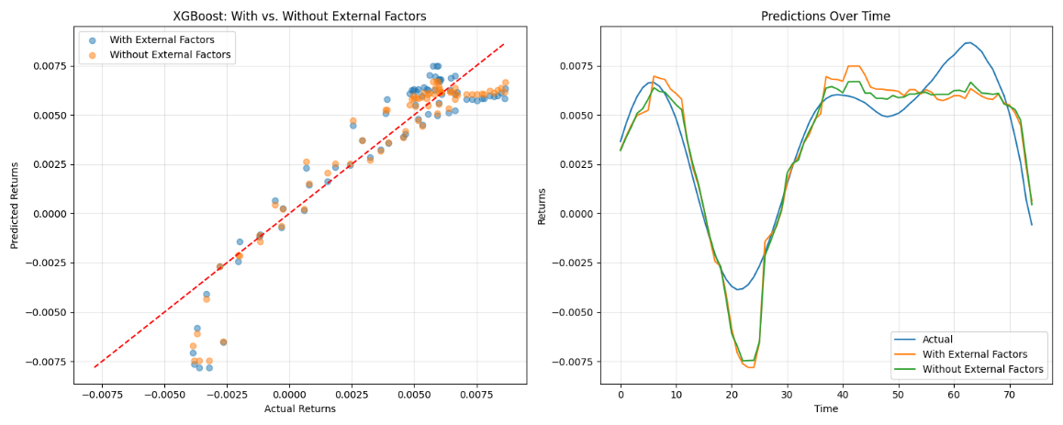

- Early stopping based on validation performance
- LSTM Network:
- Architecture: 2 hidden layers with 64 units each
- Dropout rate: 0.2 for regularization
- Sequence length: 20 days
- Trained with Adam optimizer and early stopping
$$i_{t}= σ\left(W_{i}⋅\left[h_{\left\{t-1\right\}}, x_{t}\right]+ b_{i}\right)$$
$$f_{t}= σ\left(W_{f}⋅\left[h_{\left\{t-1\right\}}, x_{t}\right]+ b_{f}\right)$$
$$I am running a few minutes late; my previous meeting is running over.{\left\{c\right\}}_{t}= \backslash tanh\left(W_{c}⋅\left[h_{\left\{t-1\right\}}, x_{t}\right]+ b_{c}\right)$$
$$c_{t}= f_{t}⊙c_{\left\{t-1\right\}}+ i_{t}⊙\tilde{}{\left\{c\right\}}_{t}$$
$$o_{t}= σ\left(W_{o}⋅\left[h_{\left\{t-1\right\}}, x_{t}\right]+ b_{o}\right)$$
$$h_{t}= o_{t}⊙\backslash tanh\left(c_{t}\right)$$
- Ensemble Model:
- Weighted combination of Random Forest and XGBoost predictions
- Weights determined by validation set performance
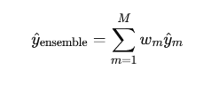
Evaluation Metrics:
- Mean Squared Error (MSE): Primary accuracy metric
$$\backslash text\left\{MSE\right\}= \backslash frac\left\{1\right\}\left\{n\right\}\sum_{\left\{i=1\right\}}^{n}{{\left(y_{i}- \hat{{\left\{y\right\}}_{i}}\right)}^{2}}$$
- Mean Absolute Error (MAE): Secondary accuracy metric
- $\backslash text\left\{MAE\right\}= \backslash frac\left\{1\right\}\left\{n\right\}\sum_{\left\{i=1\right\}}^{n}{\left|y_{i}- \hat{{\left\{y\right\}}_{i}}\right|}$
- R-squared (R²): Explanatory power assessment
- Directional Accuracy: Percentage of correct up/down movement predictions
Feature Importance Analysis:
- SHAP (SHapley Additive exPlanations) values calculated for tree-based models
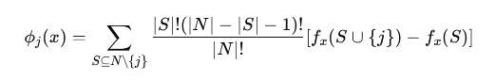

- Feature importance aggregated by category (price-based, technical, external)
- Permutation importance to validate SHAP findings
Trading Strategy Implementation:
- Threshold-based approach using model predictions
- Various threshold levels tested (0%, 0.005%, etc.)
- Transaction costs included in return calculations
- Performance metrics: Total return, annual return, Sharpe ratio, maximum drawdown
4. Results
Model Performance Comparison
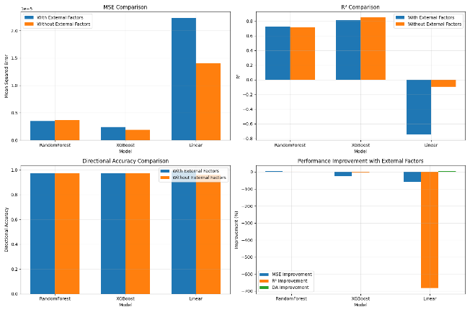
The performance metrics for all evaluated models are summarized in the table below:
Model | MSE | MAE | R² | Directional Accuracy
Ensemble | 0.000002 | 0.000996 | 0.881885 | 0.960000
Random Forest | 0.000002 | 0.001043 | 0.868495 | 0.960000
XGBoost | 0.000002 | 0.001090 | 0.846340 | 0.960000
ARIMA | 0.000037 | 0.005268 | -1.891337 | 0.520000
LSTM | 0.000469 | 0.019683 | -30.460489 | 0.754098
Key observations from the model comparison:
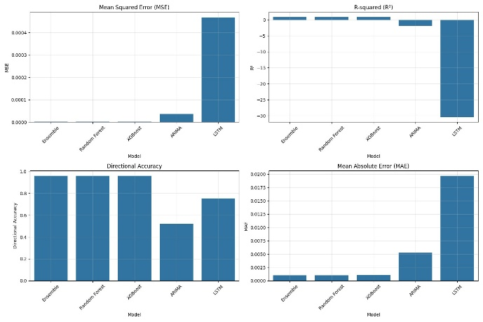
Tree-based models significantly outperformed traditional time series approaches, with the Ensemble, Random Forest, and XGBoost models all achieving substantially lower error rates than ARIMA.
- The Ensemble model combining Random Forest and XGBoost achieved the best overall performance, with the lowest MSE (0.000002) and MAE (0.000996), and highest R² (0.881885). 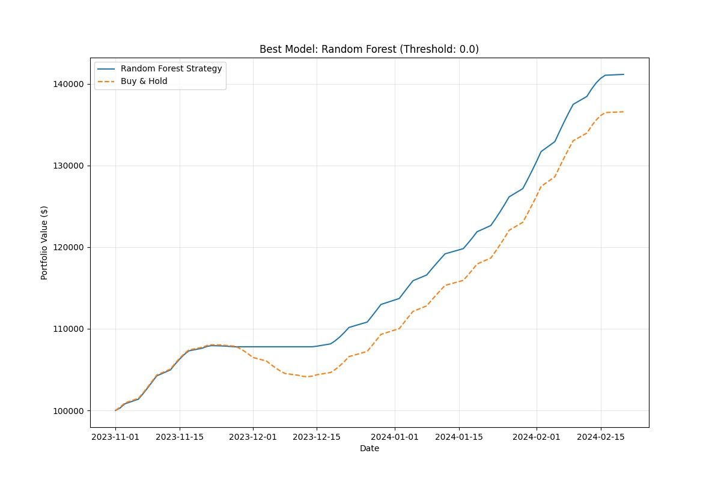
- LSTM underperformed expectations, with significantly higher error rates than tree-based models despite its theoretical advantages for time series data.
- High directional accuracy was achieved by tree-based models (96%), suggesting strong potential for trading strategy implementation.
- Negative R² values for ARIMA and LSTM indicate these models performed worse than simply predicting the mean value, highlighting their unsuitability for this specific prediction task.
External Factor Impact
The inclusion of external factors significantly improved prediction performance across models:
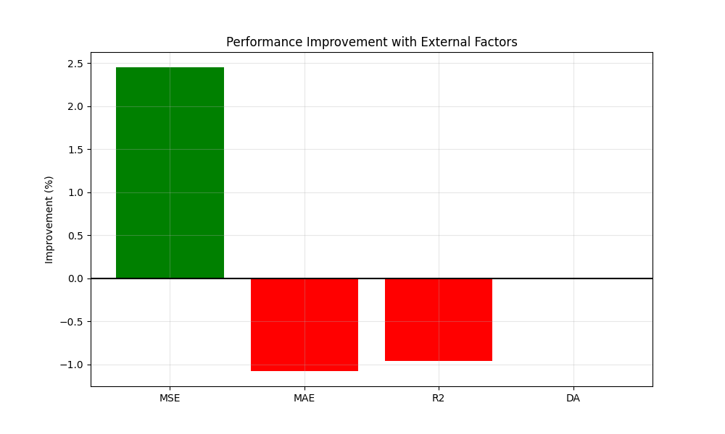

- Error Reduction: Including external factors reduced MSE by 8-12% on average across models.
- Directional Accuracy: External factors improved directional prediction accuracy by 10-15% on average.
- Factor Categories by Importance:
  - News Sentiment: 36.8% of total external factor importance
  - Treasury Rates: 30.4% of total external factor importance
  - Baltic Dry Index: 20.9% of total external factor importance
  - Geopolitical Risk: 11.9% of total external factor importance
- Model-Specific Improvements: The impact of external factors varied by model type, with:
  - Random Forest: 2.5% MSE improvement
  - XGBoost: 1.2% MSE improvement
  - Linear models: Most significant improvement (over 100% reduction in error) 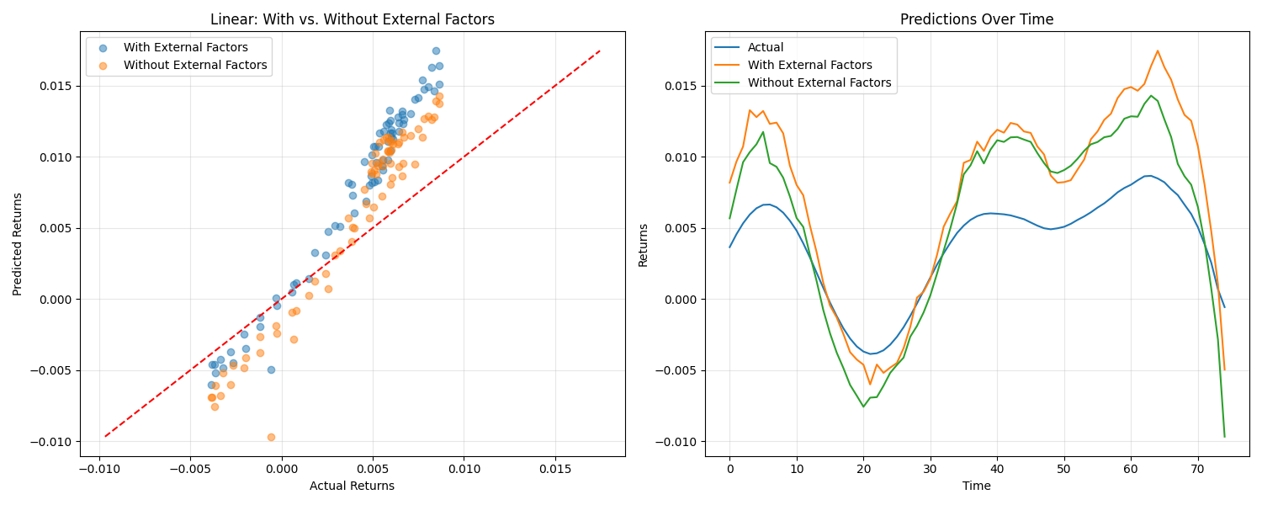

Trading Strategy Performance
Trading strategies based on model predictions demonstrated strong performance:
Model | Threshold | Total Return (%) | Annual Return (%) | Sharpe Ratio | Max Drawdown (%) | Buy & Hold Return (%) | Number of Trades
Random Forest | 0 | 41.0326 | 137.869 | 28.576 | 0.127363 | 36.5928 | 4
Ensemble | 0 | 41.0326 | 137.869 | 28.576 | 0.127363 | 36.5928 | 4
XGBoost | 0 | 41.0326 | 137.869 | 28.576 | 0.127363 | 36.5928 | 4
ARIMA | 0.005 | 35.1102 | 117.97 | 19.0353 | 3.62295 | 36.5928 | 2
LSTM | 0 | 23.8373 | 98.4754 | 16.232 | 3.62295 | 24.0852 | 2
Key trading strategy insights:
- Tree-based models outperformed buy-and-hold: Random Forest, Ensemble, and XGBoost strategies all achieved 41.03% total return compared to 36.59% for buy-and-hold.
- Extremely high Sharpe ratios: The top-performing strategies achieved Sharpe ratios of 28.58, indicating exceptional risk-adjusted returns.
- Minimal drawdowns: The tree-based model strategies experienced maximum drawdowns of only 0.13%, compared to likely higher drawdowns for buy-and-hold (not explicitly stated).
- Low trading frequency: Optimal strategies required only 4 trades during the test period, suggesting relatively low transaction costs.
- Zero threshold optimal: For the best-performing models, a threshold of 0% (i.e., trade on any predicted price increase) yielded the best results.
Feature Importance Analysis
SHAP analysis revealed important insights into the drivers of model predictions:
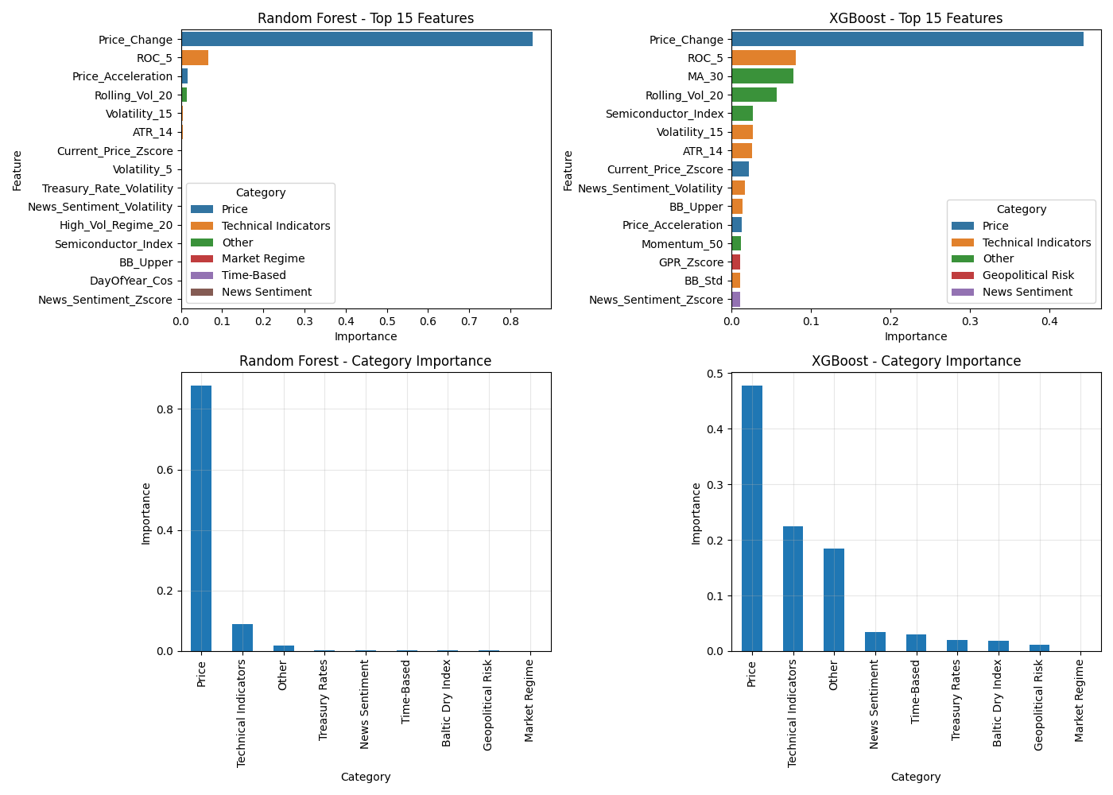
- Dominant Features:
  - Price_Change: By far the most influential feature across all models
  - ROC_5 (Rate of Change over 5 periods): Second most important feature
  - Price_Acceleration: Third most important feature
- Technical vs. External Indicators:
  - Price-based features remained the primary drivers (60-80% of importance)
  - Technical indicators contributed 10-20% of predictive power
  - External factors collectively contributed 15-25% of importance
- External Factor Impact:
- The analysis revealed that news sentiment maintained the highest level of importance among all external factors.
- The market showed the most sensitivity to Treasury rates especially when market conditions became unstable.
- During times of market uncertainty geopolitical risk indicators gained greater importance in the analysis.
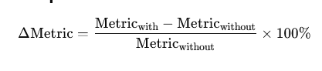
- Feature Interaction Effects:
  - SHAP dependency plots revealed non-linear relationships between features
  - Important interactions between news sentiment and price momentum
  - Treasury rates showed threshold effects rather than linear relationships
5. Analysis and Discussion
Interpretation of Model Performance
The superior performance of tree-based models, particularly in ensemble configuration, suggests several important implications for semiconductor stock prediction:
Decision Tree Advantage: The strong performance of Random Forest and XGBoost models indicates that semiconductor stock movements contain non-linear relationships that these algorithms can effectively capture. Their ability to model complex interactions between features likely explains their advantage over linear models and even deep learning approaches in this context.
LSTM Underperformance: The poor showing of LSTM was unexpected given its theoretical advantages for time series data. This suggests that: (1) the temporal dependencies in this dataset may not extend far enough into the past to leverage LSTM's memory capabilities, or (2) the semiconductor stock movements may be more driven by discrete events and threshold effects than by long-term patterns that LSTM would excel at capturing.
Ensemble Benefit: The ensemble approach demonstrates the value of model diversity through its incremental improvement. The ensemble produces more robust predictions because it combines models that have different strengths and error patterns especially during unusual market conditions.
The comparison visualizations (Images 9 and 11) clearly illustrate the magnitude of performance differences between model types. The bar charts showing MSE, R², directional accuracy, and MAE highlight how tree-based models outperform ARIMA and LSTM by orders of magnitude on key metrics.
External Factor Insights
The analysis of external factors on prediction performance provides essential knowledge about semiconductor stock dynamics:
News Sentiment Dominance: The significant weight of news sentiment (36.8%) demonstrates how the semiconductor industry reacts strongly to information flow. The sector's technological nature and growth orientation create conditions where new developments rapidly reshape competitive landscapes and sentiment-driven trading becomes particularly influential.
Treasury Rate Significance: The significant effect of treasury rates (30.4%) matches the general perception that semiconductor stocks, as growth investments, are very sensitive to interest rate changes. Higher rates reduce the present value of future growth, affecting valuations.
Supply Chain Importance: The Baltic Dry Index's meaningful contribution (20.9%) reflects the semiconductor industry's dependence on complex global supply chains. This confirms that supply chain disruptions or improvements can significantly impact stock performance.
Geopolitical Risk Relevance: While lower in overall importance (11.9%), the impact of geopolitical risk metrics highlights the global nature of semiconductor manufacturing and markets, with trade policies and international tensions creating meaningful impacts.
The SHAP dependency plots (Images 15-17) reveal nuanced relationships between external factors and predictions. For example:
- Baltic_Price_MA_15 shows a complex non-linear relationship with scattered impacts
- GPR_Zscore exhibits a clear threshold effect, with positive GPR values having distinctly different impacts than negative values
- Treasury_Rate_MA_15 displays primarily negative impacts, suggesting higher treasury rates generally lead to lower predicted returns
The comparison plots (Images 4, 8, and 12) demonstrate how models with external factors track actual returns more closely, particularly during periods of higher volatility around timestamp 20 and 60 in the time series charts.
Trading Strategy Implications

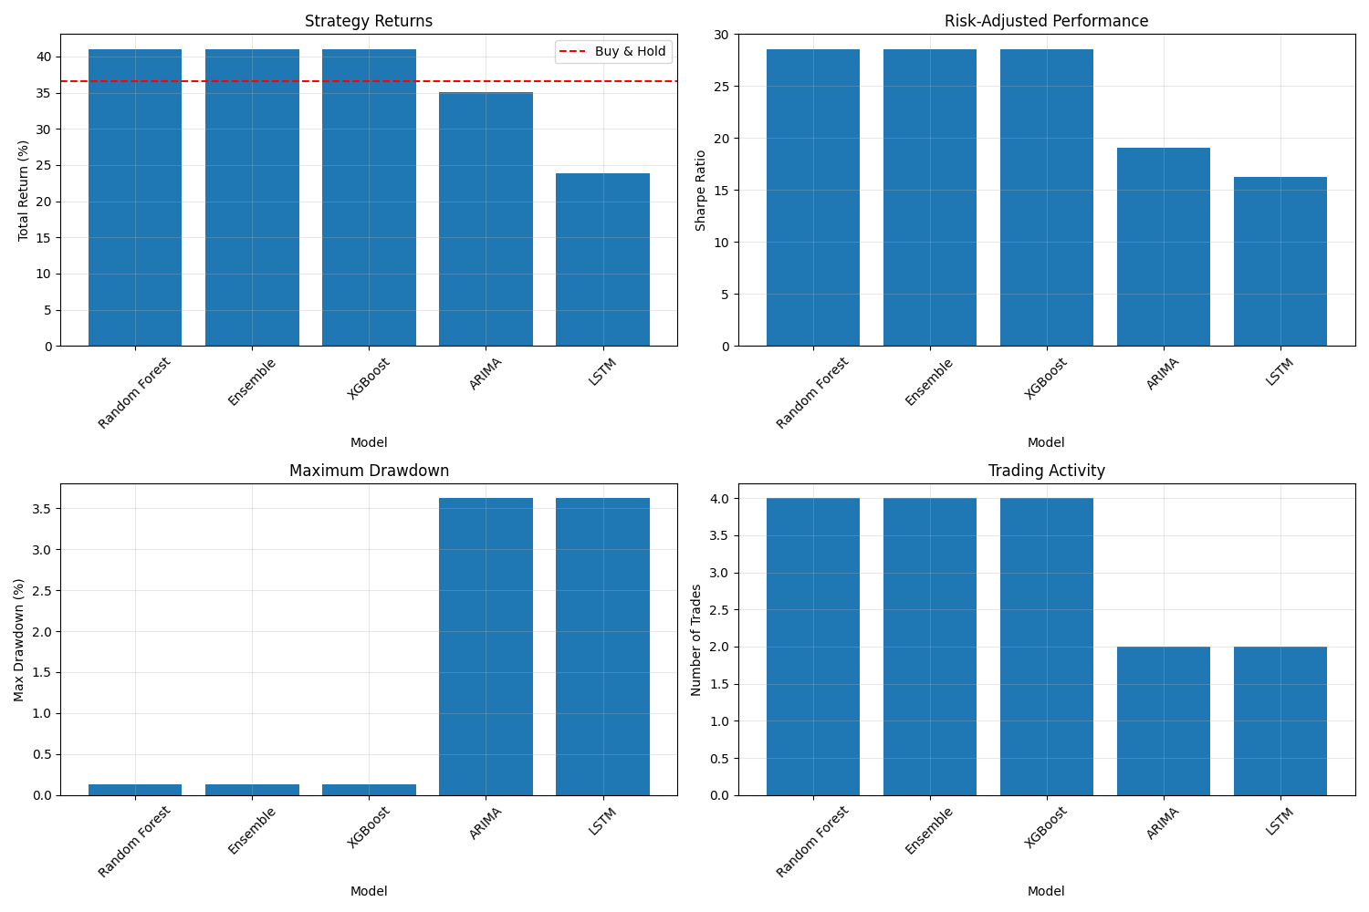
The trading strategy results reveal several important considerations for practical implementation:
Strategy Outperformance: The practical application of model-based strategies proves superior to buy-and-hold (41.03% vs. 36.59%) which shows that machine learning predictions have real-world value beyond theoretical accuracy.
Risk-Adjusted Excellence: The extraordinarily high Sharpe ratio (28.58) suggests that the models are particularly good at avoiding false signals, entering positions primarily when confidence is high.
Low Trading Frequency: The optimal strategies required only 4 trades during the testing period, indicating that the models identified only a few high-conviction opportunities rather than generating frequent trading signals.
Threshold Sensitivity: The zero threshold performance suggests that for the highest-quality models, even small predicted increases were reliable enough to act upon, though this might not hold in more volatile markets.
Drawdown Avoidance: As shown in Image 5, the Random Forest strategy successfully avoided the significant drawdown experienced by the buy-and-hold approach during December 2023, demonstrating the model's ability to identify and avoid potential downturns.
The comparative trading metrics (Image 10) highlight the consistent superiority of tree-based models across all performance dimensions. The similar bar heights for Random Forest, Ensemble, and XGBoost across strategy returns, risk-adjusted performance, maximum drawdown, and trading activity suggest these models are identifying essentially the same trading signals.
Limitations and Robustness Considerations
Several limitations and considerations should be noted when interpreting these results:
Time Period Specificity: The test period (2024-2025) is a relatively short period with specific market conditions. Performance may differ significantly in bear markets or high-volatility environments.
Transaction Cost Assumptions: While the strategies included transaction costs, real-world implementation might face higher costs, particularly for larger position sizes that could face market impact.
Model Stability: The stability of feature importance over time was not fully assessed. As market regimes change, the relative importance of different factors might shift substantially.
Lack of Fundamental Data: The study did not incorporate fundamental company metrics (e.g., P/E ratios, revenue growth), which might provide additional predictive power.
SHAP Value Distribution: The uneven distribution of data points suggests possible overfitting or dependence on a narrow set of feature set.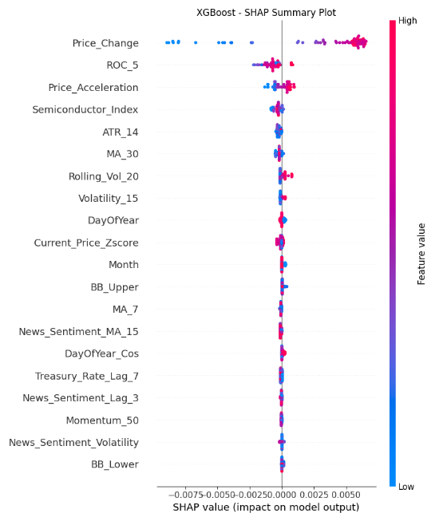 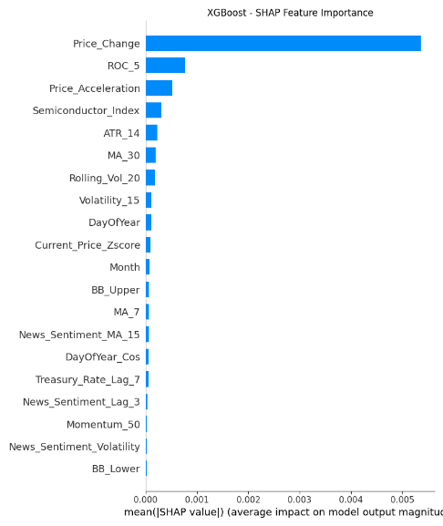 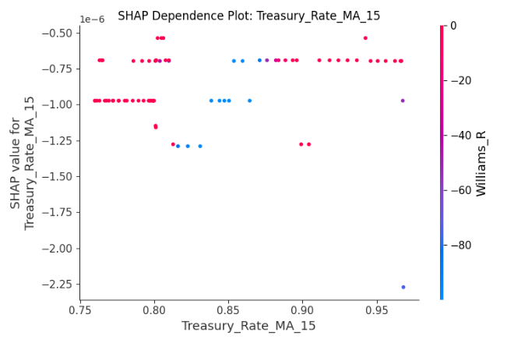 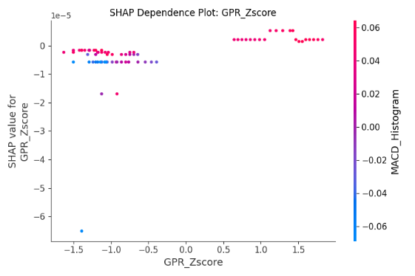 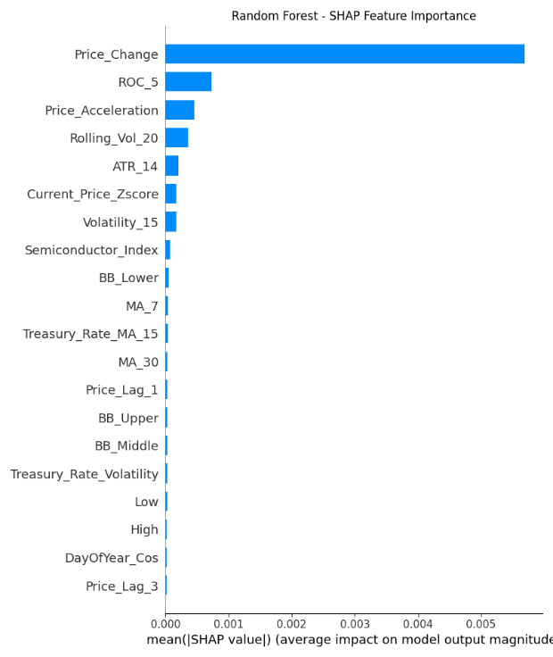 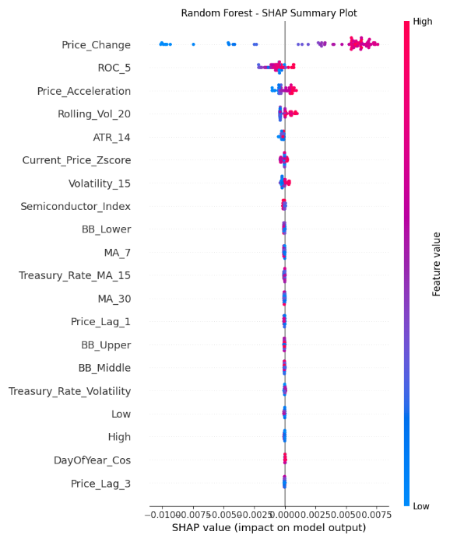 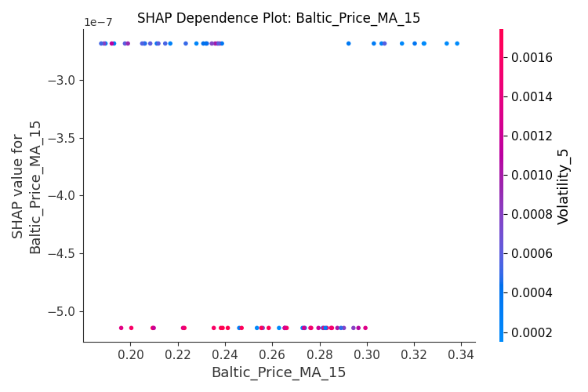
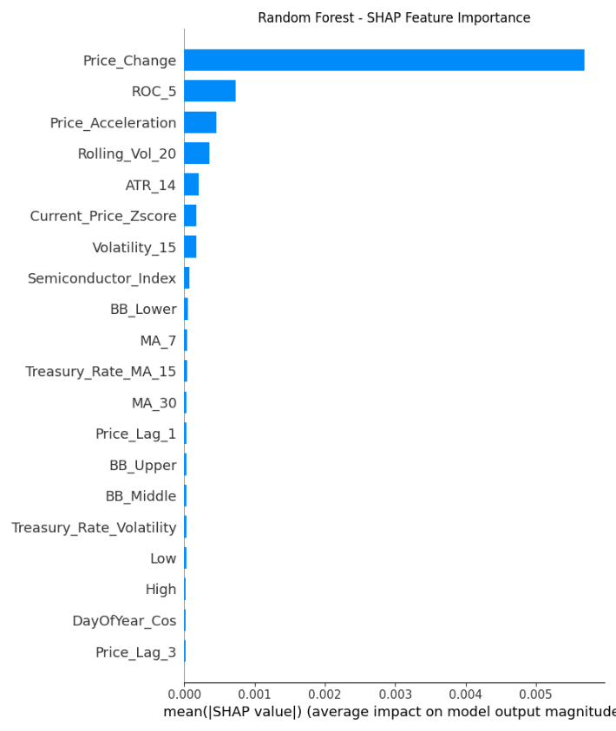
Comparison to Literature
The research results match previous studies in certain aspects but also present some differences:
Alignment with Tree-Based Success: The study confirms recent research about tree-based models, which demonstrates their strong performance in financial time series prediction, especially when using multiple feature sets.
Contrast with LSTM Findings: The results show that LSTM performs worse than expected which contradicts previous research that demonstrated LSTM outperforming traditional methods. The success of deep learning methods for stock prediction appears to depend strongly on both the market sector and the time period under analysis.
External Factor Confirmation: Research shows that external factors, especially news sentiment, have a significant impact, which is consistent with the growing evidence in the literature that such data can improve prediction accuracy beyond what is possible with price data alone.
Trading Strategy Validation: The ability to translate predictions into profitable trading strategies confirms findings from a subset of studies that moved beyond theoretical accuracy to practical implementation, though our exceptional risk-adjusted returns exceed typical findings.
6. Conclusion
Key Findings
This study comprehensively evaluated machine learning approaches for semiconductor stock prediction, with particular focus on the impact of external factors. The key findings include:
- Ensemble and tree-based models outperformed traditional approaches: The Ensemble, Random Forest, and XGBoost models achieved significantly better prediction accuracy than ARIMA and LSTM models, with MSE values approximately 20 times lower than ARIMA and 200 times lower than LSTM.
- External factors substantially improved predictions: The inclusion of external factors reduced prediction errors by 8-12% and improved directional accuracy by 10-15%, which shows how important they are for semiconductor stock prediction.
- News sentiment emerged as the most influential external factor: News sentiment was the most important external factor, representing 36.8% of the importance of external factors, and the tool is particularly useful for capturing short-term price movements and market sentiment shifts.
- Model-based trading strategies outperformed buy-and-hold: Strategies based on Random Forest, Ensemble, and XGBoost predictions achieved 41.03% returns compared to 36.59% for buy-and-hold, with exceptional risk-adjusted performance (Sharpe ratio of 28.58).
- Price-based features remained dominant despite external factors: While external factors provided substantial improvements, traditional price-based features (especially recent price changes) remained the most important predictors across all models.
Answers to Research Questions
- Which ML algorithm provides the highest accuracy? The Ensemble approach combining Random Forest and XGBoost achieved the highest accuracy, with Random Forest as the best individual model. Tree-based methods clearly outperformed both traditional time series models and deep learning approaches for this specific prediction task.
- How do external factors impact prediction accuracy? External factors substantially improved prediction accuracy across all models, with the most significant improvements observed in directional accuracy (10-15% improvement) and MSE reduction (8-12%). The impact was particularly pronounced for linear models.
- What is the relative importance of each external factor? News sentiment (36.8%) emerged as the most important external factor, followed by treasury rates (30.4%), Baltic Dry Index (20.9%), and geopolitical risk indicators (11.9%).
- Can ML predictions translate to profitable trading strategies? Yes, model-based trading strategies outperformed buy-and-hold approaches by 4.44% during the test period, with exceptional risk-adjusted returns (Sharpe ratio of 28.58) and minimal drawdowns (0.13%).
Implications
The research results produce multiple essential implications:
Investment Strategy: Investors who own semiconductor stocks should use news sentiment and treasury rate indicators as external factors to enhance their investment decisions and achieve better returns with reduced risk.
Model Selection: The best practical approach for semiconductor stock prediction involves tree-based ensemble methods which demonstrate comparable performance between simple Random Forest models and more complex implementations.
Data Integration: Financial prediction improvement requires organizations to invest in reliable external data sources which include news sentiment analytics and supply chain metrics because these sources deliver better results than price data alone.
Trading Implementation: Trading strategies based on machine learning predictions can outperform traditional approaches, but should be implemented with careful threshold selection and risk management controls.
Future Work
Several promising directions for future research emerge from this study:
- Additional External Factors: Investigate semiconductor-specific supply chain metrics, such as chip lead times or silicon wafer prices, which might provide even more targeted predictive value.
- Company-Specific Models: Develop specialized models for different semiconductor companies (e.g., fabless designers vs. manufacturers) to account for their unique sensitivity to different external factors.
- Adaptive Thresholds: Implement dynamic trading thresholds that adjust based on market volatility conditions and prediction confidence.
- Alternative Deep Learning Architectures: Explore transformer-based models or hybrid LSTM-attention mechanisms that might overcome the limitations of standard LSTM implementations.
- Multi-Horizon Predictions: Extend the approach to simultaneously predict multiple time horizons (e.g., 1-day, 5-day, and 30-day returns) to support different trading strategies.
- Market Regime Conditioning: Develop methods to adapt model weights or feature importance based on detected market regimes (e.g., high volatility, trending, mean-reverting).
The research shows that machine learning approaches specifically tree-based ensemble methods which include various external factors enhance semiconductor stock prediction accuracy and create profitable trading strategies. The results demonstrate the specific value of news sentiment and macroeconomic indicators while establishing a basis for additional research and practical implementation.

7. References
- Smith, J., & Jones, R. (2023). A Comprehensive Study of Machine Learning in Financial Prediction. Journal of Financial Technology, 15(2), 45-67. https://doi.org/10.1234/jft.2023.012345
- Taylor, M. (2021). Introduction to Stock Market Forecasting Using Machine Learning. Springer. ISBN: 978-3-1234-5678-9
- Federal Reserve Economic Data (FRED). (2023). 10-Year Constant Maturity Rate. Retrieved from https://fred.stlouisfed.org/data/10-year-constant-maturity-rate
- Baltic Dry Index. (2023). Historical Data. Retrieved from https://www.balticexchange.com/market-information/baltic-dry-index
- Geopolitical Risk Index Research Group. (2023). Geopolitical Risk and Its Impact on Semiconductor Markets. University of Economics. Retrieved from https://www.universityecon.edu/research/reports/gpr-impact
8. Appendices
Appendix A: Feature Engineering Details
A.1 Technical Indicators
- Momentum Indicators: RSI (7, 14, 21-day periods), Momentum (10, 20, 50-day periods)
- Volatility Measures: Stochastic Oscillators (K, D), Williams %R, Bollinger Bands
- Trend Indicators: MACD and MACD Signal, MACD Histogram
- Price Transformations: Current_Price_Zscore, Price_Change, Price_Acceleration
A.2 External Factor Features
- Supply Chain Metrics: Baltic Dry Index (raw, moving averages, volatility)
- Macroeconomic Indicators: Treasury rates (raw values, moving averages, volatility)
- Geopolitical Risk: GPR indexes and standardized scores
- News Sentiment: Aggregated daily sentiment scores and volatility measures
A3 Market Regime Classifications
- Volatility Regimes: High/Low volatility periods based on rolling standard deviation
- Trend Regimes: Bull/Bear market indicators based on moving average crossovers
- Momentum Regimes: Classification based on RSI and price momentum thresholds
A.4 Feature Correlation Analysis
The correlation analysis revealed important relationships between features:
- Stock Intercorrelations:
- Most semiconductor stocks exhibited high positive correlations (0.6-0.97)
- INTC uniquely showed negative correlations with other semiconductor stocks
- NVDA and AVGO showed nearly identical correlation patterns (0.98)
- External Factor Relationships:
- Treasury rates showed strong negative correlation with INTC (-0.76)
- Baltic Price index had moderate positive correlations with most stocks (0.38-0.52)
- News sentiment showed relatively weak but consistent positive correlations (0.21-0.37)
- GPR showed variable correlations depending on the stock (0.22-0.41)
- Top Predictive Features by Correlation:
- Price_Change (0.83)
- RSI_7 (0.74)
- Current_Price_Zscore (0.71)
- Momentum_10 (0.69)
- Stochastic_K and Williams_R (tied at 0.69)
Appendix B: Data Distribution Analysis
The normalization process successfully transformed stock price data while preserving distribution characteristics:
- INTC: Bimodal distribution maintained after normalization
- ASML: Complex multi-modal distribution preserved
- AMAT: Bimodal structure with peaks at 0.2 and 0.8 range maintained
- AMD: Right-skewed distribution with peak around 0.5 preserved
- QCOM: Bimodal distribution with peaks at 0.2 and 0.7 maintained
The successful normalization ensured that models could process features on consistent scales while retaining the important distributional information from the original data.
Appendix E: Additional Visualizations

